 

Flight Finder:Navigating your air travel options   
Team ID : LTVIP2025TM ID49881   
Team Leader : Alavalapati Chethana   
Team member : Kamalapuram Pathan Suhana Team member : Yanamala Lakshmi Kumari   
Team member : B Vishnu Priya   
Team member : M C Jayamma   
Team member : Palagiri Venkata Chaithanya

ELECTRONICS AND COMMUNICATIO ENGINEERING

COLLEGE:Kandula lakshumma memorial college of engineering for women   
OBJECTIVE:   
To navigate air travel options, you can utilize flight finders like Google Flights, Skyscanner, or M omondo to

  

search for flights, compare prices, and track fares. You can also use apps like ixigo and Flightradar24 for tracking flights and finding deals.

TOOLS AND TECHNOLOGIES USED:

*Flight Search Engines   
* Flight TrackingApps   
* Price Comparison & Deals   
* Flexible Travel Dates   
DATA BASE DESCRIPTION:

 

 

.Go destinationsbased on price and date google Flights: Use the "Explore" feature to discover potential

● Skyscanner: Offers"Search Everywhere" and "Cheapest Month" optionsfor flexible travel planning.

● Momondo: Providesprice alerts, trendingcities, and flight trackers.

COM M ON VARIABLES:

W hen navigating flight options, several common   
variables play a crucial role in finding the best deal and suitable itinerary. These include departure and arrival airports, travel dates, number of passengers, and desired cabin class. Additionally, factors like airline preference, layovers, and desired baggage allowance can influence the final choice.

 

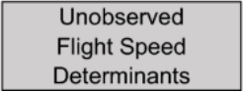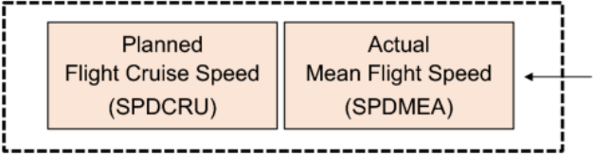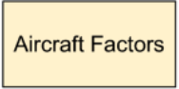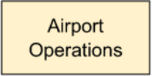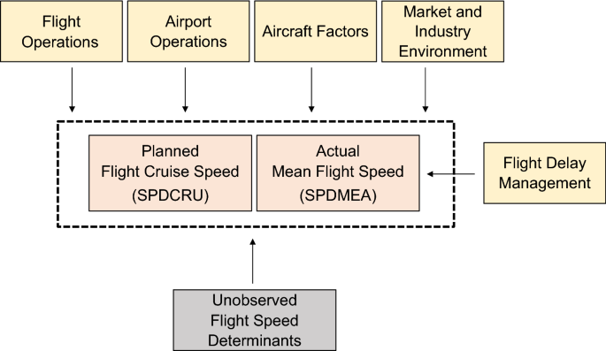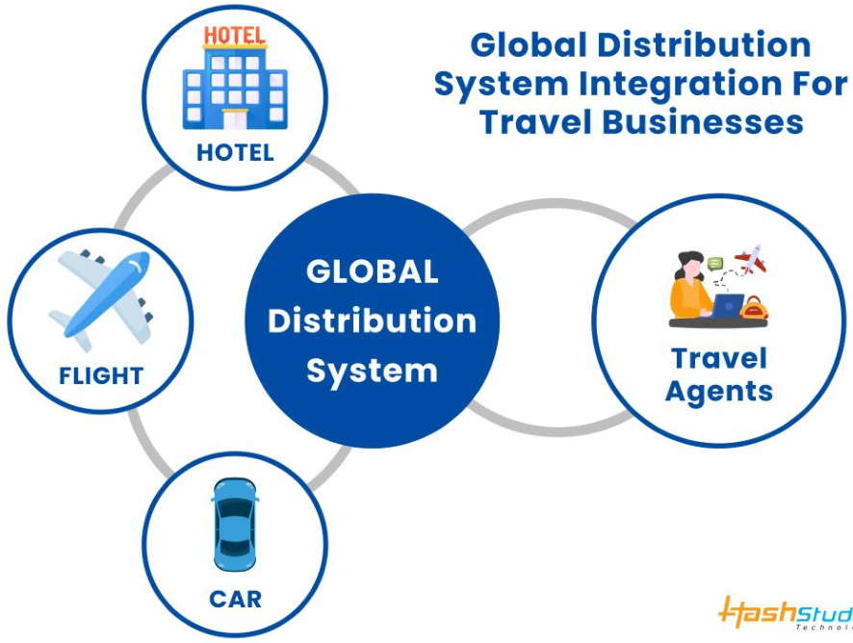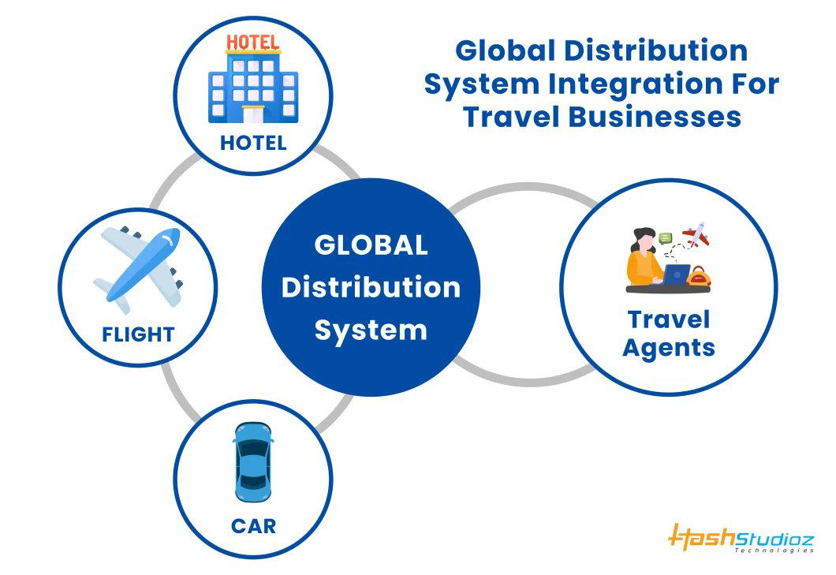

 



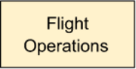

 

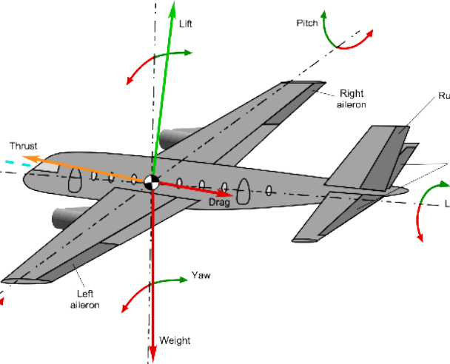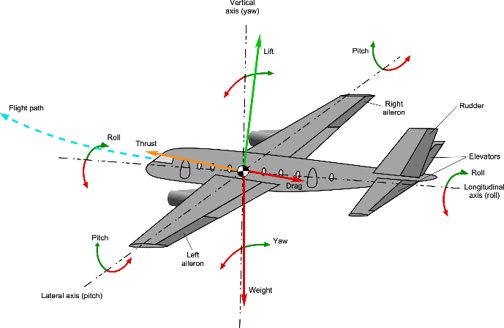

|  |  |  |
| --- | --- | --- |
|  |  |  |



 

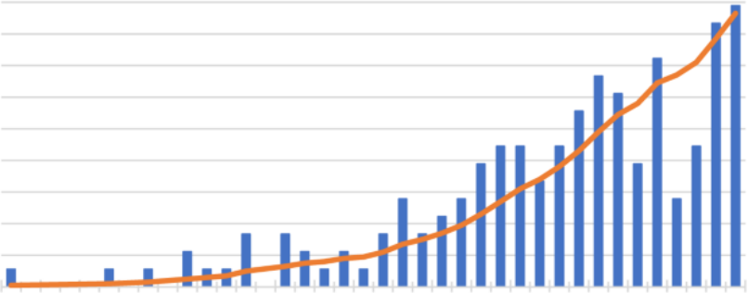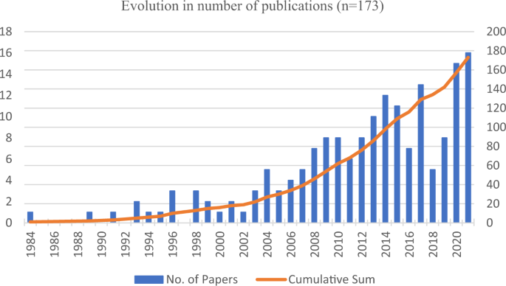

|  |  |  |  |  |  |  |
| --- | --- | --- | --- | --- | --- | --- |
|  |  |  |  |  |  |  |



REFERENCE:

BookingReference/PNR/Record Locator:

Airline Reference Number:

Airline W ebsite/App:

 

 

CONCLUSION:

Flight search and reservation algorithms are the   
backbone of modern travel. They involve complex   
processes of data retrieval, normalization, query   
processing, pricing, and ensuring a smooth user   
experience. W hile the examples provided are simplified, real-world systems need to consider many more factors, including security, scalability, and real-time updates. As technology advances, these algorithms continue to evolve, providing travelers with more choices

 